**2.1.1 Outline the cell theory (2).**

*Outline*: To give a brief account or summary.

* All living things are made of cells.
* Cells are the smallest unit of life.
* Existing cells have come from other cells.
* Stated in this way Cell Theory might be attributed to Schleiden and Schwann (1838).
* Robert Hooke first coined the term 'cell' after observing the structure of cork in 1655.
* The first observation of living cells was by Anton van Leeuwenhoek in 1674.

**2.1.2 Discuss the evidence for the cell theory (3).**

*Discuss:* Give an account including, where possible, a range of arguments for and against the relative importance of various factors, or comparisons of alternative hypotheses.

***a. All living things are made of cells***:  
  
When living things are observed under the microscope they *consistently* appear to be composed of cells.

However, there are a number of examples that do not conform to the standard notion of what a cell looks like at the microscopic level.

Exceptions the that test the rule of cell theory:   
  
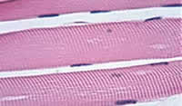**Muscle cells:** challenges the idea that a cell has one nucleus.  
Muscle cells have more than one nucleus per cell  
Muscle Cells called fibres can be very long (300mm).  
They are surrounded by a single plasma membrane but they are multi-nucleated.(many nuclei).

This does not conform to the standard view of a small single nuclei within a cell.

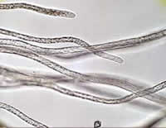

**Fungal Cells**: challenges the idea that a cell is a single unit.  
Fungal Hyphae: again very large with many nuclei and a continuous cytoplasm

The tubular system of hyphae form dense networks called mycelium.

Like muscle cells they are multi-nucleated

They have cell walls composed of chitin

The cytoplasm is continuous along the hyphae with no end cell wall or 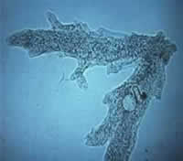membrane

**Protoctista:** Challenges the idea that a cell is specialised to a single function. Yet, the protoctista can carry out all functions of life.  
A cell capable of all necessary functions Amoeba Single celled organisms have one region of cytoplasm surrounded by a cell membrane.   
The protoctista cell is unusual in that it performs all functions. Such cells are usually much larger than other cells such that some biologist consider them 'acellular', that is, non-cellular.  
This is an image of an amoeba. A single cell protoctista capable of all essential functions. What cell organelles can you see?

***b. Cells are the smallest unit of life.***

* The cell is the smallest unit of organization that can show all the characteristics of living processes.
* Organelles often require the cooperation of other organelles for their successful function.
* Interested students should research the concept of endosymbiont theory.

***c. Cells come only from other cells***.

Where do cells come from?

* Cells carry out a form of cell division to form new cells. This process of cell replication in eukaryotes is called mitosisand in prokaryotes is called [binary fission.](http://click4biology.info/c4b/2/cell2.2.htm#fission) The parental cell divides to produce identical daughter cells.
* This aspect of cell theory suggests that all cells therefore have a common ancestor, the original ancestral cell form which all other cells have arisen by descent. (origin of cellular life).
* This relationship of common ancestor suggest thereof re that all organisms are related.
* TOK: Cell theory replaces the former ideas of [spontaneous generation](http://en.wikipedia.org/wiki/Germ_theory_of_disease) or [abiogenesis](http://en.wikipedia.org/wiki/Abiogenesis) in which inanimate matter assembles itself into living forms. This was particularly believed to be the case in out breaks of diseases. These ideas are then replaced by the work of [Francesco Redi](http://en.wikipedia.org/wiki/Francesco_Redi), [Agostino Bassi](http://en.wikipedia.org/wiki/Agostino_Bassi), [John Snow](http://en.wikipedia.org/wiki/John_Snow_%28physician%29) and [Louis Pasteur](http://en.wikipedia.org/wiki/Louis_Pasteur). There still remains the necessary idea however that at some point cellular life developed from non-cellular form. No doubt this pre-cellular form was a replicating macromolecule perhaps like RNA. Much of this discussion is based on the notion that life takes cellular form and that it is possible to define the exact boundary between living and non-living. There are scientist who suggest that too much importance is attached to the resolution of the question and that the definition of 'life' is of little value.

**2.1.3 State that unicellular organisms carry out all the functions of life (1).**

*State*:means to give a specific name, value or other brief answer without explanation or calculation.

These organisms are able to carry out all the processes which are characteristic of living things such as:

a***. metabolism*** which includes respiration the synthesis of ATP.   
b. ***response*** to a change in the environment   
c. ***homeostasi****s* the maintenance and regulation of internal cell conditions.   
d. ***growth*** which for a unicellular organism means an increase in cell size and volume.   
e. ***reproduction*** which for the unicellular organism is largely asexual through cell division to form a clone.   
f. ***nutrition*** which means either the synthesis of organic molecules or the absorption of organic matter.

**2.1.4 Compare the relative sizes of molecules, cell membrane thickness, viruses, bacteria, organelles and cells, using the appropriate SI unit (3)**

*Compare*: means to Give an account of similarities and differences between two (or more) items, referring to both (all) of them throughout.

We depend on the microscope for our observation of cellular structures. Observations of this type are for the most part dependable but we must consider the introduction of 'artifacts' by those processes that prepare the material for microscopy. These artifacts are a consequence of specimen dehydration, contrast enhancement (staining), radiation and microscope function. These artifacts can lead to image or data distortions and misinterpretation.

1. 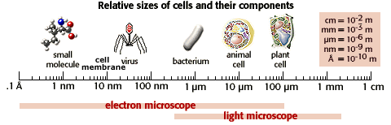**Relative sizes**:  
   1. molecules (1nm).   
   2. cell membrane thickness (10nm).  
   3. virus (100nm).  
   4. bacteria (1um).  
   5. organelles (less 10um).  
   6. cells (<100 um).  
   7. generally plant cells are larger than animal cells.

nm= nanometer (10-9m)        um= micrometer (10-6m)

* Molecules of Biological significance are around 1 nm in size where as the cell membrane is about ten times thicker at 10nm.
* Where as a virus is ten times larger again at around 100nm.
* where as a bacteria is ten times larger again at around 1 um.
* where as a eukaryotic animal cell is is ten time larger again at around 10 um.
* where as a eukaryotic plant cell is ten times larger again at around 100 um.

**2.1.5 Calculate the linear magnification of drawings and the actual size of specimens in images of know magnification (2).**

*Calculate* means find a numerical answer showing the relevant stages in the working (unless instructed not to do so).

On an image of a specimen it is useful to show how much larger/smaller the image is than the real specimen. This is called magnification.

**Exercise 1: Find a leaf, any leaf around 10-15 cm in length.**

1. Draw the leaf exactly the same size as the it is in life, add the vein patterns and note the vein pattern at the edges of the leaf.
2. Make sure you measure length and breadth of the leaf.
3. Add labels for structure
4. If you know the name of the species of plant that the leaf comes from add this information.
5. A a title 'A diagram to show the structure of a Helianthus spp. leaf'.
6. Finally add the magnification as x 1 in the right hand bottom corner of the diagram (but prominent).

**Exercise 2: Increasing the magnification.**

1. You must now draw the leaf again but this time doubling every measurement
2. Compete your diagram with the label x 2.

**Exercise 3: Decreasing the magnification**

1. You must now draw the leaf again but this time half all measurement and dimension.
2. Add the label x 0.5
3. This means that all dimension have been decreased by one half of the original value.

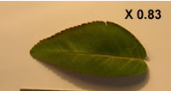**Calculate magnification from an image:**

using a ruler measure the size of a large clear feature on the image

Measure the same length on the specimen

convert to the same units of measurement

* **Magnification = measured length of the image /measured length of the specimen**
* **Length of the actual specimen = length on the image/ magnification ( e.g. rose leaf = image length 4.2cm/ magnification 0.82 = 5cm real length**

**Scale Bars**: images often carry a scale bar which is a horizontal line drawn on the image. The scale bar shows how long the line is in the real specimen.

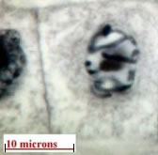This example shows a plant cell.

The scale bar indicates the length of 10 microns = 10um

Notice that 10 um is about the vertical length of the diameter of the nucleus.

All other measurements from the image are made relative to this scale bar.

If you measure the actual length of the nucleus in this image and there is a scale bar you can calculate the magnification of the image. See the formula above if you require assistance.

**2.16 Explain the importance of the surface area to volume ratio as a factor limiting cell size (3).**

Explain means to give a detailed account of causes, reasons or mechanisms.

* As the size of a structure **increases** the surface area to volume ratio **decreases.**
* Reasoning: This can be seen by performing some simple calculations concerning different-sized organisms.

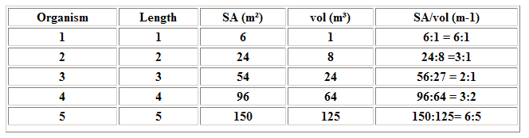

* The rate of exchange of substances therefore depends on the organism's surface area that is in contact with the surroundings.
* Reason: as organisms get bigger their volume and surface area both get bigger, but not by the same amount. The volume increases as the cube but the area of the surface only increases by the square.
* **Conclusions:**
  + As the organism gets bigger its surface area : volume ratio decreases
  + This rule is a limiting factor for cell size.
  + As the cell gets bigger the ratio decreases
  + If the ratio decreases the rate of exchange decreases

Example: gas exchange of oxygen for respiration.

* + A cell which respires aerobically demands oxygen for the process.
  + Oxygen is obtained form the surrounding environment such as water or blood (depends on the cell).
  + Oxygen diffuses across the cell membrane.
  + More membrane more diffusion (Surface area= increases by the 2).
  + Bigger cell (Volume = increases by the 3).
  + However the ratio of surface area2 : volume 3 is decreasing
  + Therefore the volume of oxygen obtained for each unit of cell volume is actually decreasing
  + Cells must not get too big because they cannot obtain sufficient oxygen to satisfy the demands of the cell.

Why cells are small (reasoning):

* + Size as a limiting Factors for cell because:
  + A big cell needs more oxygen than a little cell
  + Big cells need to have more oxygen diffusion across the cell membrane.
  + But the big cell has relatively small surface area compared to its volume i.e. the surface area: volume ratio is small.
  + What ever other benefits a cell might gain from being big, it cannot become larger than is limited by the rate of gas exchange.
  + This reasoning can be applied to nutrients and to waste, anything that is exchanged across the cell surface.
  + Try preparing a reason why size is a limiting factor for:
  + Obtaining nutrient (glucose)
  + Excretion of waste molecules ( urea, ammonia, carbon dioxide).

**2.1.7 State that multicellular organisms show emergent properties (1).**

*State*:means to give a specific name, value or other brief answer without explanation or calculation.

syllabus: 'Emergent properties arise from the interaction of the component parts; the whole is greater than the sum of the parts'.

Systems biologists attempt to put together the parts that make up a system and then observe the properties of that 'emerge' from the system but which could not have predicted from the parts themselves.

As a model consider the electric light bulb. The bulb is the system and is composed of a filament made of tungsten, a metal cup, and a glass container. We can study the parts individually how they function and the properties they posses. These would be the properties of :

* Tungsten
* Metal cup
* Glass container.

When studied individually they do not allow the prediction of the properties of the light bulb. Only when we combine them to form the bulb can these properties be determined. There is nothing supernatural about the emergent properties rather it is simply the combination of the parts that results in new properties emerging.

Emergence,reductionism and Biology 2

The approach of the physical sciences is to reduce an inanimate phenomenon to its constituent parts and that knowledge of these will explain the phenomena as a whole. The parts do not vary (otherwise there would be more parts) and these are predictable within the laws and principles that describe them. Since the smallest parts are predictable then the system as a whole is predictable. No new properties will arise from the sum of the parts, this is *explanatory reductionism*.

Biological systems need a different approached, *population thinking*, which acknowledges the role of variation in a population. Consequently the deterministic laws and theories of the physical sciences do not apply to all aspects of biological systems. The ‘parts’ of the living system vary on both a phenotypic level and at the level of the genetic program. This is an important feature of the biological system (compared to the non-living) which is affected by both the physiochemical laws and also by a genetic program.

*Theory reduction* is the concept that theories and laws in one science field are simply special cases of theories which are to be found in the physical sciences.

*Emergence* is the occurrence of unexpected characteristics or properties in a complex system. These properties emerge from the interaction of the ‘parts’ of the system. Remember that biology insists on a population thinking so that we know the interacting ‘parts’ vary in themselves and therefore their ‘emerging’ properties can only be generalized. On a biological scale consider the current debate about the nature of human consciousness or the origin of life itself.

**2.1.8 Explain that cells in multicellular organisms differentiate to carry out specialized functions by expressing some of their genes but not others (3).**

Explain means to give a detailed account of causes, reasons or mechanisms.

* An interesting parallel with economic theories is that the *larger collective economic group the greater the number of specialisms*, (Adam Smith) a rough guide which is found to hold true in living systems.
* As a general principle then we find that the larger a multicellular organisms become the more diversity and differentiated specialisms there are within the organism.
* Rather than all cells carrying out all functions, tissues and organs specialise to particular functions. These organs and systems are then integrated to give the whole organism (with its emergent properties).
* Differentiation: Cells within a multi cellular organism specialise their function.
* Specialised cells have switched on particular genes (expressed) that correlate to these specialist functions.
* These specific gene expressions produce particular **shapes, functions** and adaptations within a cell.
* Therefore a muscle cell will express muscle genes but not those genes which are for nerve cells.
* What is the benefit of differentiation and specialisation of tissues rather than all tissues carrying out all functions?
* In a multi cellular organism specialisation is more efficient than the generalised plan when competing for a specific resource. Consider the role of water transport through the plant:

1. In higher plants we have specialisation to for a tubular system called the xylem.
2. This is more efficient way of water transport than simply been passed by the mass movement of water from cell to cell.
3. In the xylem water can be moved very efficiently from underground to the canopy of the highest trees at very little cost to the plant.
4. If there is no specialised tissue for carrying water then the plant would rely on the movement of water by mass flow of diffusion which is very slow. The plant is therefore limited in size and therefore cannot compete with larger species.

The study of how animal cells become specialised is called embryology. This study area in biology has been developing very fast in recent time. Some of the discoveries about why some embryonic cells become nerves, muscles or blood cells has led to new ideas about the evolution of life. The new discipline is called evolutionary developmental biology or 'Evo-devo'. The following text is a great introduction to what will become one of the most important aspects of biology for this new century.

**2.1.9 State that stem cells retain the capacity to divide and have the ability to differentiate**

**along different pathways(1).**

*State*:means to give a specific name, value or other brief answer without explanation or calculation.

* 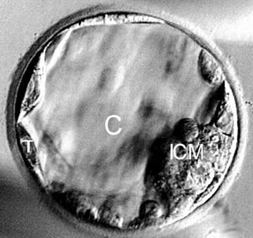A stem cell retains the capacity to divide and has the ability to differentiate along different pathways.
* A stem cell is able to divide but has not yet expressed genes to specialise to a particular function. Under the right conditions stem cells can be induced to express particular genes and differentiate into a particular type of cell.
* Stem cells can be obtained from a variety of different places including the blastocyte. Adults still posses stem cells in some organs but much less so than a child. Even the placenta can be a useful source of stem cells.

**2.1.10 Outline one therapeutic use of stem cells (2).**

Outline means to give a brief account or summary.

Non-Hodgkins Lymphoma is a cancerous disease of the lymphatic system.

1. patient requires heavy does of radiation and or 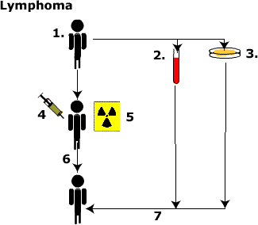chemotherapy. This will destroy health blood tissue as well as the diseased tissue.
2. Blood is filtered for the presence of peripheral stem cells. Cells in the general circulation that can still differentiate into different types of blood cell otherwise known as stem cells.
3. Bone marrow can be removed before treatment.
4. Chemotherapy supplies toxic drugs to kill the cancerous cells.
5. Radiation can be used to kill the cancerous cells. In time however the cancerous cells adapt to this treatment so that radiation and chemotherapy are often used together.
6. Post radiation/ chemotherapy means that the patients health blood tissues is also destroyed by the treatment.
7. Health stem cells or marrow cells can be transplanted back to produce blood cells again

You may wish to think about more elaborate forms of stem cell therapy. The following information provides an introduction to these technologies.

2. **Embryonic Stem cell** therapy [this animation](http://www.dnalc.org/stemcells.html) is an excellent introduction to the use of embryonic stem cell for therapies.

**3. Therapeutic cloning** . This is a method of obtaining ES cells from someone who has already been born. These stem cells can be used to treat the individual without generating an **immune response**. The human body recognizes and attacks foreign cells, including stem cells. This is a *serious barrier* to stem cell therapy.

The process of therapeutic cloning is shown in this **diagram**. It begins by taking a somatic (body) cell from the individual. The somatic cell is fused with an egg that has had its nucleus removed. The resulting cell is genetically identical to the individual because it contains the DNA from the individual’s somatic cell. The new cell behaves like a fertilized egg and develops into a blastocyst. ES cells can be harvested from the blastocyst and grown in culture. These ES cells could be used to treat the individual without encountering resistance from his or her immune system.

Notice that we do not not refer to this type of blastocyst as an embryo. This is because, technically speaking, an embryo is the result of the union of an egg and a sperm, which has not happened in this case.

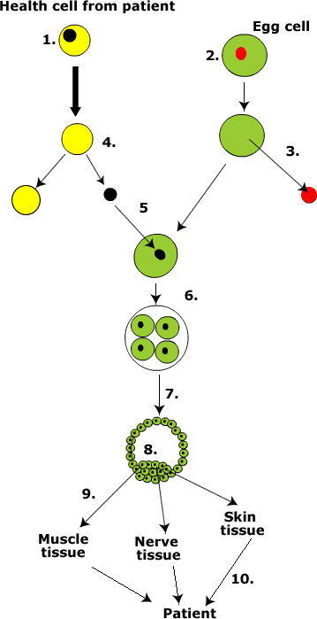

1. The patient requires the replacement of some diseased tissue. First we obtain a health cell from the same patient.
2. At the same time we require a human egg cell. This is mainly as the cell retains the tendency to divide unlike the sample tissue from the patient.
3. The nucleus is removed from the egg and discarded. The cell body itself is retained.
4. The nucleus of the patients cell is removed and retained. The cell body of the patients cell is discarded.
5. The nucleus from the patients cell is transferred to the enucleated cell body.
6. The cells then stimulated to divide forming a clone.
7. The cell mass forms a blastocyst.
8. The inner cell mass becomes a source of totipotent stem cells. Totipotent means they are capable of being stimulated to become one of any type of cell.
9. Cells are stimulated using *differentiation factors* to become the type of cell required for therapy.
10. Therapy would require the transfer of the new healthy cell to the patient. In therapeutic cloning these cells have the same immune system identity as the patient therefore there is not immune rejection problem.

It is important that this technique is not confused with embryonic stem cell cultures or with reproductive cloning.